MAT502 Name_______________________________________________

Lab 3.2 Minimizing the Distance between four houses

In this lab, you will look at a real world problem, come up with an algebraic model for it, see a visual justification of your model, look at it graphically and solve it using calculus.

Part I

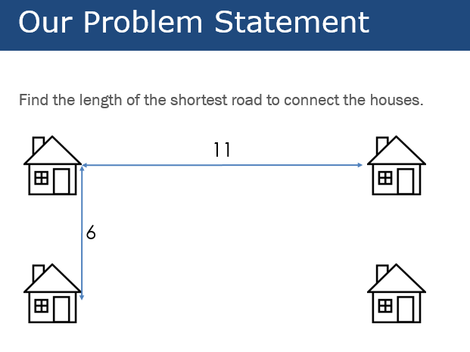

You may assume that you want to find the shortest path that connects all four houses. It may be any shape you can come up with. Spend about 5-10 minutes with your group trying to find some values for distances and approximating which you believe is shortest.

Write down some of your guesses for which you think was the shortest. Show your work and calculations.

Part II: Demonstration with Soap Bubbles

Watch the demonstration and use what you see to find another possible shortest distance. It may be that the demonstration validates one of the possibilities that you had in Part I. How does the phenomenon with the soap bubbles show which is the shortest path?

Part III: Algebraic Model

With your group and an idea of the path that gives you the shortest distance. Write an algebraic function for the path itself,  You may use the numbers 6 and 11 from the diagram, but you will get more points if you can do it in terms of more general variables  (width) and  (length).

Part IV: Geometric Model

Graph your Algebraic Model in Desmos or GeoGebra and find the minimum value. Record where the minimum occurs so that you have a comparison. (Keep your graph for your Lab Write Up)

Part V: Solving with Calculus

Using your function  for the length of the path, use methods of calculus to find the minimum distance. Comment on anything interesting that you find about the critical points at which you find the minimum path.